Overview of Teaching and Learning of PE
Intent
Through the three ideas of community, opportunities and possibilities and significance, with an over-arching link to the Christian and British values, our children will grow into individuals that will have the skills and mindset to leave Primary School with the capabilities to be successful.
In physical education, children will develop into confident, proud children who all have an enjoyment for physical activity. Children will have developed physical skills and values which they can take with them into their future and will impact on the wider curriculum as they have a strong belief in their abilities as well as improved concentration, behaviour and focus throughout all education and beyond. Children will also have the confidence and ability to interact socially, interact with others and present themselves so that they stand out with pride. They will understand the importance of physical activity in all aspects of life and through this, children will have a strong sense of wellbeing and can use it to feel happier and healthier.
BIG IDEAS:
In line with every subject in Hintlesham and Chattisham Primary. The three Big Ideas for PE are:

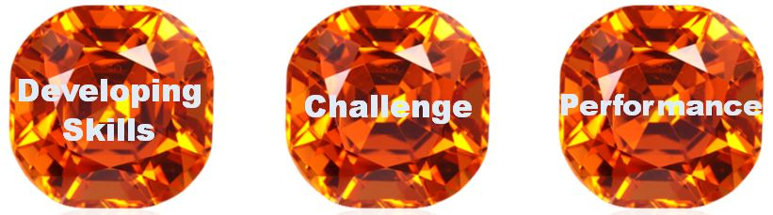
All lessons should contain an aspect of each of the big ideas although they may be weighted differently from lesson to lesson.
Develop Skills – Children continually learn new skills and develop existing skills to a high standard. These skills include social, emotional and thinking skills in order to develop the whole child.
Challenge – Children are physically active for sustained periods of time, choose from the skills they have developed and apply them correctly and reflect on and evaluate their performance in order to improve.
Performance – Children develop confidence and capability to apply skills in a performance environment either through matches, tournaments, productions, displays or performances to an audience.
Vision:
We intend our children to become

- Happy with an enjoyment of physical activity
- Confident to participate, perform and develop own learning
- Determined to achieve their full potential
- Driven to develop themselves through understanding and challenge
- Positive and determined to approach challenges for a sustained period
- Proud of their own and others’ achievements

Implementation
The benefits of a high-quality physical curriculum are valuable in the development of our children. At the heart of education of all children in school is physical, social, cognitive and emotional development. Through a high-quality physical curriculum, including physical activity, physical education, sport and dance, children will become confident and proud through a high self-esteem and belief. They will develop an enjoyment of a healthy, active lifestyle as well as participation and competitiveness through tournaments and performance opportunities. We will produce independent learners with a strong desire to improve through resilience, commitment, understanding and cooperation with others, therefore impacting on relationships, personal well-being, communication and a sense of identity.
As well as not developing these traits, children who do not receive a high-quality physical curriculum can have a poor idea of body image/size and lack of understanding of the benefits of a healthy, active lifestyle. Attendance can also be affected as children develop a negative attitude toward physical activity and education, this can then impact further with poor behaviour, lack of concentration and not interacting with peers.

In order to meet our vision, we have the expectation that children will develop the following skills and characteristics:

Characteristics | Skills
Confident  Positive  Determined  Committed  Willing  Independent  Focussed  Proud  Respectful  Supportive  Honest  Creative  Cooperative | Problem Solving  Communicating  Selecting  Applying  Assessing  Reflecting  Understanding  Persevering  Celebrating  Collaborating  Leading  Empathising  Decision Making

We use these at the basis of all planning and pedagogy within the physical curriculum in order for all children to feel success and achieve to their ability as well as celebrating and respecting the success of others.

- Long term plans on a two-year rolling programme that cover a wide range of sporting activities ensuring progression through each lesson, unit and year on year
- 8 week units to ensure full coverage of skills within each unit and allowing time for performance element at the end of each unit
- Teachers to ensure powerful and memorable learning that provides a good range of activities that, together, ensure adequate breadth, balance, depth and significance to our children.
- Good use of time, space, people and resources throughout the physical curriculum
- Sports specialists used to teach sports and allow for staff development whenever possible.
- Engagement for all in a wide variety of local sporting tournaments eg trampolining, table tennis, cross country, rugby and cricket
- Assessment using the ASCA criteria
- Annual Sports Activity Day/Week
- Additional opportunity to be physically active whenever possible; Wild Woods, active cross-curricular activities, lunchtime and breaktime activities, classroom brain breaks, after school clubs, enrichment activities through workshops, trips out etc
From our Curriculum Plan we ensure that each unit provides coverage of breadth, depth, balance, significance and challenge.
Breadth: A range of activities with enough variety to suit all children’s needs and desires
Depth: Sufficient time is allocated to ensure children have the opportunity understand and apply skills in the activity. Children have the confidence to perform
Balance: Activities cover a range that enables skills to be developed leading to a balanced body
Significance: Activities consider the whole child. Each child feels that the activity is significant for them and is important to them
Challenge: The activities ensure the children can perform well and can be proud of their achievements from an accurate level of complexity and intensity

Our curriculum plan is set out in the Curriculum Long Term Plan document. Whilst the plan has been designed and set out carefully, teachers are expected to use their assessment This includes:
- shortening or lengthening time spent on a unit where necessary
- adapting the space to suit the learners and activities
- using additional staff where available as required
- grouping children in a way that suits
- adapting the activities or the final task where necessary
- reflecting on each lesson to ensure continuity into the next whilst maintaining progression but also achievement

Impact
By the end of their schooling at Hintlesham and Chattisham C of E Primary School, pupils will have been given the opportunity to apply their acquired skills in a range of competitive situations against themselves, peer-to-peer as well as school to school. They will have taken part in a range of activities, both familiar and those that are new to them, and been offered a variety of extracurricular, physically demanding activities. Through these children will have developed confidence in their own abilities, an understanding of fairness as well as teamwork and respect. We aim to foster a love of physical activity in any of its forms.
We measure the impact of our curriculum through the following methods:
- Participating in the School Games Marks award
- Taking part in local tournaments and events
- Children’s engagement in extra-curricular activities
- Pupil and parent perception surveys
- Assessment using the ASCA criteria following the National Curriculum statements
- Children in our school being able to explain to another how they try to keep healthy through exercise and diet. When asked, a child can give an example of how someone could stay healthy.

