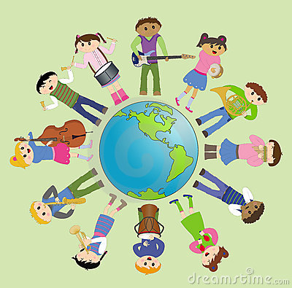

A Parents’ Guide to the Early Years Foundation Stage Framework.

What is the Early Years Foundation Stage?
Welcome to the Early Years Foundation Stage (EYFS), which is how the Government and early years professionals describe the time in your child’s life between birth and age 5.
This is a very important stage as it helps your child get ready for school as well as preparing them for their future learning and successes. From when your child is born up until the age of 5, their early years experience should be happy, active, exciting, fun and secure; and support their development, care and learning needs.
Nurseries, pre-schools, reception classes and childminders registered to deliver the EYFS must follow a legal document called the Early Years Foundation Stage Framework.
What is the EYFS Framework?
The EYFS Framework exists to support all professionals working in the EYFS to help your child, and was developed with a number of early years experts and parents.
In 2012 the framework was revised to make it clearer and easier to use, with more focus on the things that matter most. This new framework also has a greater emphasis on your role in helping your child develop.
It sets out:
- The legal welfare requirements that everyone registered to look after children must follow to keep your child safe and promote their welfare
- The 7 areas of learning and development which guide professionals’ engagement with your child’s play and activities as they learn new skills and knowledge

Ensuring your child’s safety
Much thought has been given to making sure that your child is as safe as possible. Within the EYFS there is a set of welfare standards that everyone must follow. At Hintlesham and Chattisham C.E. primary school the staff in Ruby Class has regular training in Food Safety for preparing snack time, current E.Y.F.S. practices, first aid training, Safe Guarding and Child Protection.
How will my child be learning in Ruby Class?
The EYFS Framework explains how and what your child will be learning to support their healthy development.
Your child will be learning skills, acquiring new knowledge and demonstrating their understanding through 7 areas of learning and development.

Children should mostly develop the 3 prime areas first. These are:
- Communication and language;
- Physical development; and
- Personal, social and emotional development.

These prime areas are those most essential for your child’s healthy development and future learning.
As children grow, the prime areas will help them to develop skills in 4 specific areas. These are:

- Literacy;
- Mathematics;
- Understanding the world; and
- Expressive arts and design.

These 7 areas are used to plan your child’s learning and activities. The professionals teaching and supporting your child will make sure that the activities are suited to your child’s unique needs. This E.Y.F.S. curriculum is tailor-made for your child, and it is designed to be really flexible so that staff can follow your child's unique needs and interests. There is a balance of child initiated activities and teacher directed activities in Class One.
Children in the EYFS learn by playing and exploring and being active, this learning takes place both indoors and outside.
The importance of Purposeful Play based learning activities in Ruby Class.
Play is fun for children. Play is the way children learn.
Through play, children learn about themselves, their environment, people and the world around them. As they play, children learn to solve problems and to get along with others. They enhance their creativity and develop leadership skills and healthy personalities. Play develops skills children need to learn to read and write.
Play in early childhood is the best foundation for success in school.
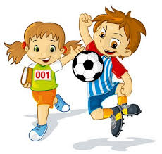

Home/School Diary – a link between learning at home and learning at school.

Each week you will receive details of your child’s learning for the next week, in their Home/School Diary. Please write regular comments in this Home/School Diary so that we can share learning experiences at home and at school.

How can I help with my child’s learning?
All the fun activities that you do with your child at home are important in supporting their learning and development, and have a really long lasting effect on your child’s learning as they progress through school.
Enjoy fun activities at home together, such as

- Sing and tell nursery rhymes
- Cook / bake together
- Explore the park at different times of the year – go off the beaten track
- Share a book /magazine/comic/information book/recipe/poem/rhyme...
- Visit the local library in Hadleigh or Ipswich together.
- Talk to your child about what they are doing
- Play board games together such as snakes and ladders.
- Go on a number hunt together.
- Follow your child’s interests and join in with their play.

Please see our school website for further information too.

How can I find out how my child is getting on?
It is important that you and the professionals caring for your child work together. You need to feel comfortable about exchanging information and discussing things that will benefit your child. These conversations will be with your child’s class teacher or “key person”.
This is the person who:
- Is your main point of contact within the setting
- Helps your child to become settled, happy and safe
- Is responsible for your child’s care, development and learning
- Takes a careful note of your child’s progress, sharing this with you and giving you ideas as to how to help your child at home.

At school, there will be regular opportunities for you to meet with your child’s teacher at Parents Evenings to discuss your child’s progress. You will be able to share your child’s Tapestry E-Learning Journey, which details observations made in all areas of learning. You will have the opportunity to share your comments on a termly “jigsaw page,” collated within your child’s Learning Journey.

At the end of the EYFS, in the summer term of the reception year in school, teachers complete an assessment which is known as the EYFS Profile. This assessment is carried out by the reception teacher and is based on what they, and other staff caring for your child, have observed over a period of time. You will receive an annual report at the end of the summer term which includes a summary of your child’s EYFS achievements.

E.Y.F.S. experiences in Ruby Class.
At Hintlesham and Chattisham C.E. Primary School we believe that all children are entitled to the best educational experiences that can be offered. We believe that this should be met through a child centred approach where individual needs are provided for through an Early Years Foundation Stage curriculum which is broad, balanced, appropriately differentiated and which provides challenge. We believe children should feel safe and secure and valued as individuals and that they are entitled to be educated in an atmosphere which is positive, stimulating and motivating, where independence and positive attitudes to learning are fostered and where each child is encouraged to reach their full potential regardless of their ethnic, socio – economic background, race, gender or ability. The positive partnership between parents and school is vital, to ensure that your child has a wonderful start to their education at Hintlesham and Chattisham C.E. Primary School. “Welcome to Ruby Class!”
Should you have any queries regarding the Early Years Foundation Stage curriculum, please do not hesitate to discuss these with me, thank you.
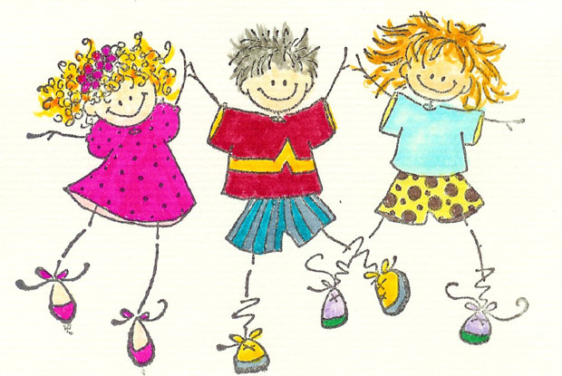

Mrs J Bensley Class Teacher.
Mrs C Bailie Teaching Assistant.

